
Building Better Futures International
Winter Newsletter 2024

www.bbf-intl.org.uk

Dear Friend of BBFI
Our last newsletter told you about our work to provide help with education for very poor Dalit rural village children. 250 a year seize this opportunity with all their might. Some have even gone on to college, even though their parents can’t read or write.
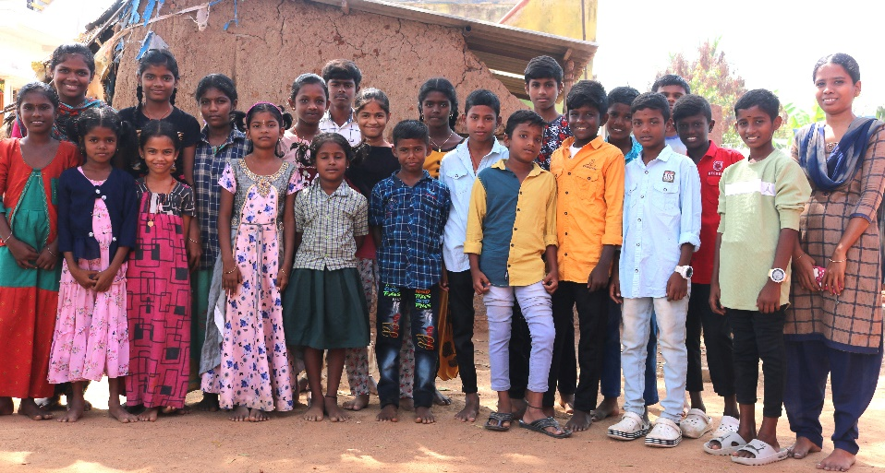
But now news of another poor community
A few years ago three of our trustees paid to go to visit our projects and saw there a vast area of parched countryside where only spiteful thorn bushes can grow. But they also saw smoke rising from large mounds with impoverished people cutting the thorn branches with machetes and piling them up. It’s dangerous work, hands and bodies scarred by the thorn. And they work in the 40 degree heat of the blazing Indian sun. They set fire to the mounds of thorn to make charcoal, but if the fire goes out they have to crawl into the mound to see what is amiss. Many are burnt or die in the process. But they still only earn one pound a day, if they’re lucky.
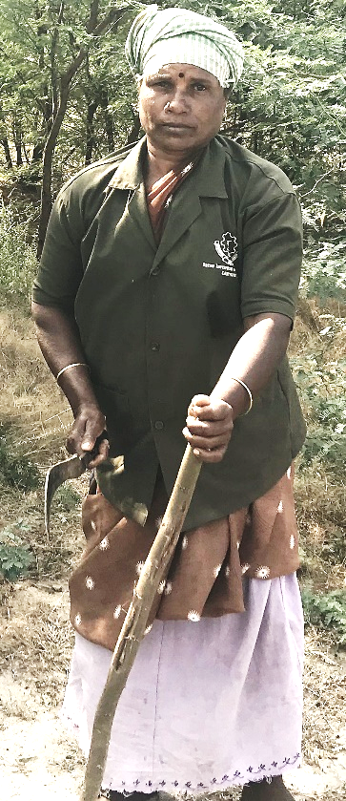
One haggard elderly woman pleaded with our trustees – “Please can you get us out of this hell?” She turned out to be no more than 30 years old but she was enslaved to this work in order to feed her family.
The trustees knew something had to be done so we have started tailoring courses for these women. In all as many as 150 women have each received six months free training. We then lend them the money (interest free) to buy a sewing machine so they can start their own small business or work in nearby garment factories. In either case, they more than triple their incomes whilst avoiding the terrible conditions in the thornbush. And it isn’t just one woman that we are helping each time: we estimate that for each woman trained at least six other people in her family are lifted out of poverty.
We’d like to expand our work in this community. Most of these impoverished families have children who often get little to no help in school. They all come from the Dalit caste (what used to be called ‘untouchables) so the women and children often receive brutal treatment. We would therefore like to expand our very successful evening tuition programme to seven villages in the charcoal burning community. This would give a real chance for 140 children each year to go on to secondary school and escape brutal lives as charcoal burners.
We’ve only been able to achieve the success we have so far because of your generosity, and we can’t continue or expand this work without your help. But we’d love to keep true to our motto: ‘Helping the Poor to Help Themselves’. Will you help us get them out of these terrible working conditions?
Sevanthi’s Story
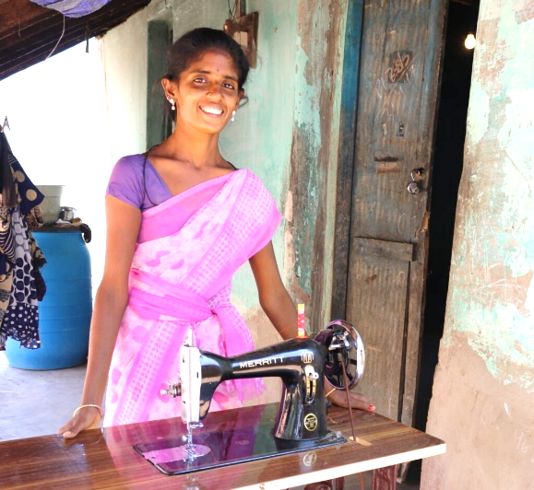
Sevanthi was working in 45 degrees C in the charcoal burning community. When we met her, she had no future. So we enlisted her in our training course. She was in our very first intake of students, but she almost wasn’t able to attend despite her enthusiasm because her husband was against it. Being an illiterate man he found it difficult to understand. One of our team’s outreach workers visited the family and persuaded her husband of the opportunity at hand.
She completed the course and received her sewing machine on the revolving-funds scheme and is now making money so she can provide food and clothing for her family. She is an inspiration to the other women in her village.
But none of this would have been possible without your own wonderful generosity. Do remember that our small charity is different from others. We ourselves pay all overheads so every penny you give goes to the poor. Check us out on our website:
www.bbf-intl.org.uk
– and thanks again!
Best wishes for Christmas and the New Year,
The BBFI Team
- £55 buys a tailoring course for a woman
- £35 buys a poor child’s tuition for a year
- £100 supplies her with a sewing machine
- £7 buys 4 pairs of children’s sandals
- £35 buys a child’s tuition for a year
- £560 pays for a teacher’s annual salary

- £20 buys a malnourished orphan
a 4-month food supplement

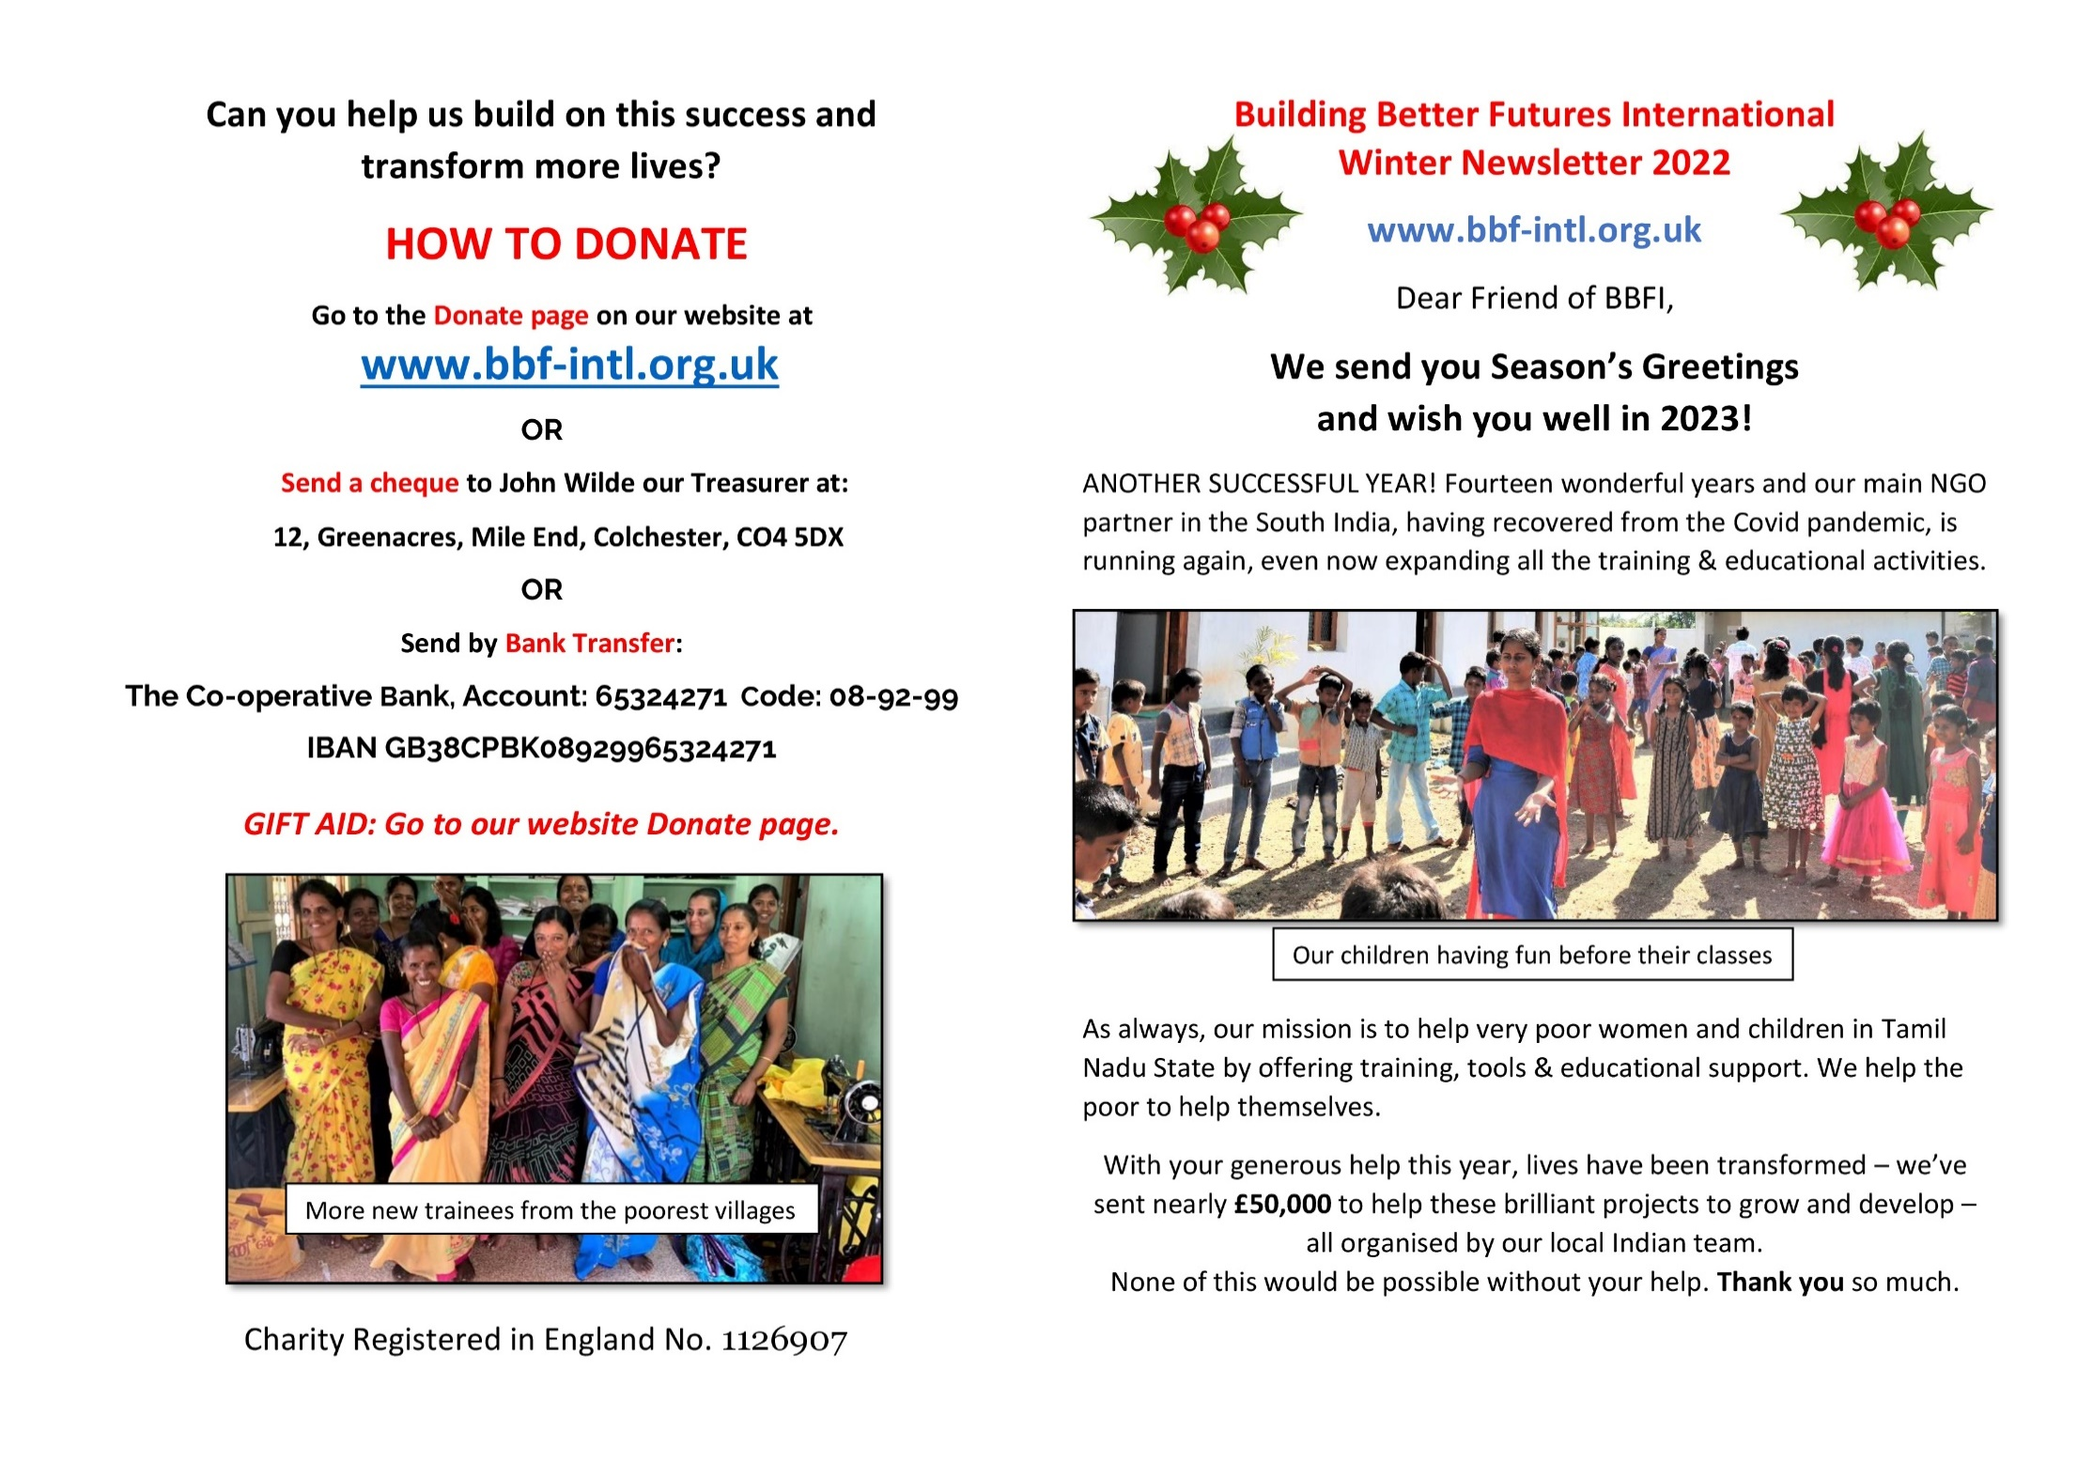
Can you help build on this success and
transform more lives?
HOW TO DONATE
Go to the Donate page on our website at
www.bbf-intl.org.uk
OR
Send a Cheque to John Wilde our Treasurer at:
12, Greenacres, Mile End, Colchester, CO4 5DX
OR
Send by Bank Transfer:
Account number: 65324271
Code: 08-92-99

GIFT AID: on the donate page
or from chair@bbf-intl.org.uk

