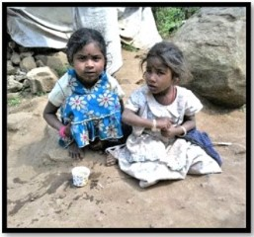

Building Better Futures International
Summer Newsletter 2024
www.bbf-intl.org.uk

Dear Friend of BBFI
A great big Thank You goes out to you all for helping us support some of the poorest women & children in India, giving them a future to look forward to. To keep you up to date with how your donations are now helping, we’ll be trying to send you not one but two Newsletters a year in future. Each one will concentrate on a particular programme because there’s so much to tell. This time we’ll focus on the children.
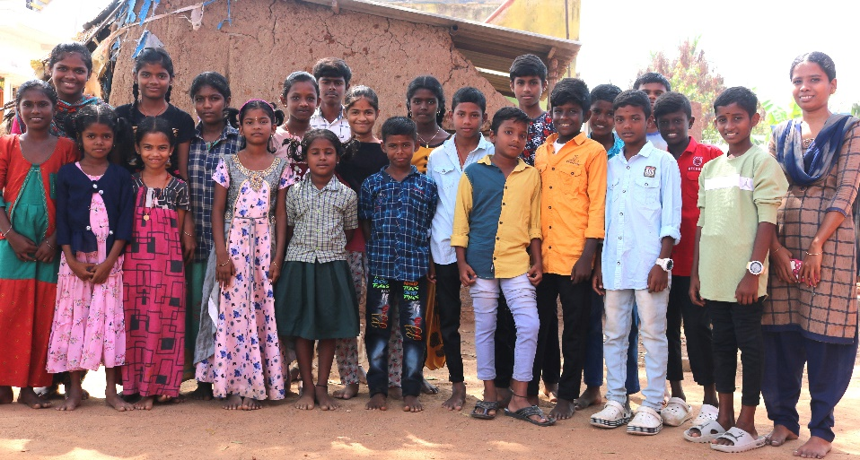
But first, some other programmes!
More than One Hundred women are receiving Tailoring Training in our three village centres. The flourishing tailoring Co-op is expanding too. Interest-free loans allow women to buy their own handlooms, freeing them from very exploitative middle-men. We’ve also successfully done the same for cow-rearing and rope making. Our motto is: ‘Helping the Poor to Help Themselves’.
And poor they certainly are!


Our Indian partner team itself is now learning to raise more funding through its own activities. You’ll remember you helped create a Coconut Plantation for them which after five years is now producing an income for the projects – this year more than £3,000 – a handsome sum in the poor villages. And they’ve begun goat rearing for the same purpose.
And so – to our Children’s Programme!
Three of our Indian children wanted to share with you a typical day in their life, so we’ve made a video all about it. It’s at: https://vimeo.com/865214893/2d8efede1e
Remember these are Dalit (untouchable) children, in dire need of support. We’ve therefore set up health days, with a doctor offering check-ups and ongoing advice. Also, they often receive only meagre education in crammed classrooms with no tables or chairs, and with illiterate parents unable to help. We have therefore, through our Indian partner team, opened ten evening tuition classes in their remote villages – 20 boys & girls in each.
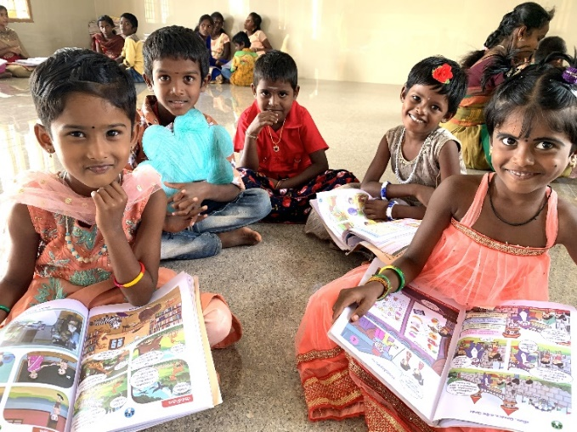
They attend for two hours each evening with our trained, caring teachers. On starting, they’re given their first school satchel filled with school essentials, plus their first pair of sandals!
In addition, you’re providing them with the first outings and sports days they’ve ever known. We even have them coming to our new computer training centre!
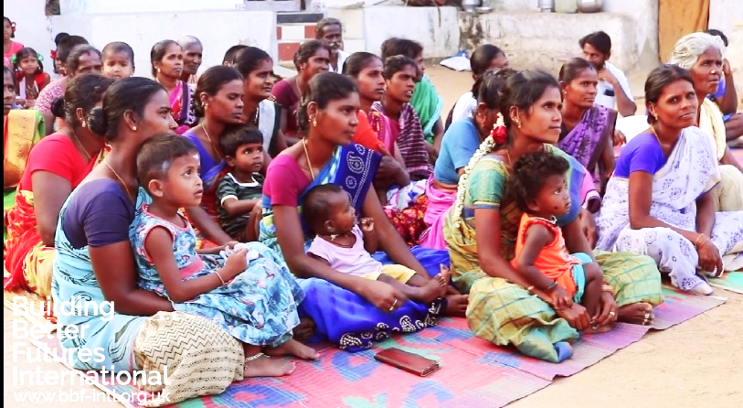
They’ve worked so hard and it's all so successful that from their very low base, hundreds have now been enabled to go on to secondary school and just last year our first four ‘graduates’ started at University! Their illiterate parents now come excitedly to parents’ evenings and take great pride in what their own children are achieving. And it’s all down to you!

And what does all this cost? Believe it or not, just £35 gives each child a whole year’s evening tuition or the highest standard.
Can you think of a better investment?
It’s costing us £7,000 a year to run this programme so we really do need your continuing help. Thank you so much!
Best wishes and thanks from us,

The BBFI Team

- £7 buys 4 pairs of children’s sandals
- £28 buys a 6-month computer course
- £30 buys a satchel full of books
& equipment
- £35 buys a poor child’s tuition for a year
- £50 for a qualified Doctor’s clinic
- £20 buys a malnourished orphan
a 4-month food supplement
- £60 buys desks for 6 to share
- £100 buys prizes & medals for children
- £400 sends 230 children on
their first day’s outing or a Sports Day
- £560 pays for a teacher’s annual salary
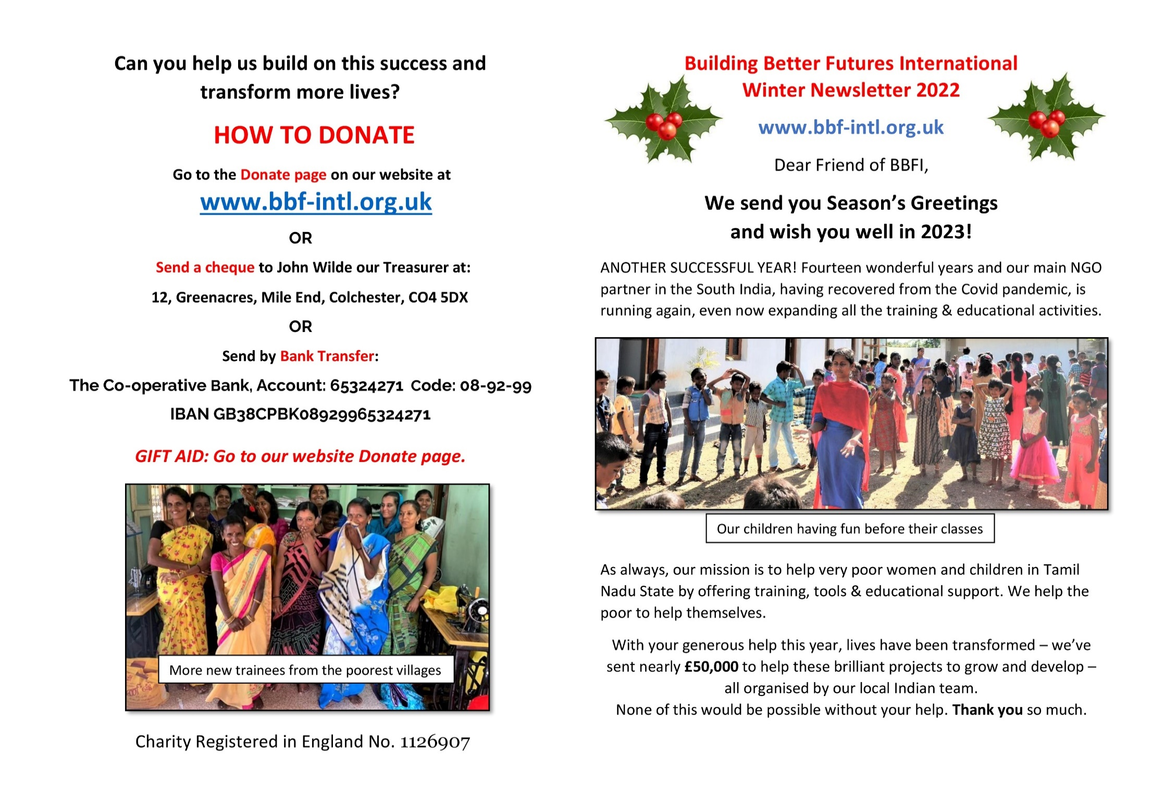
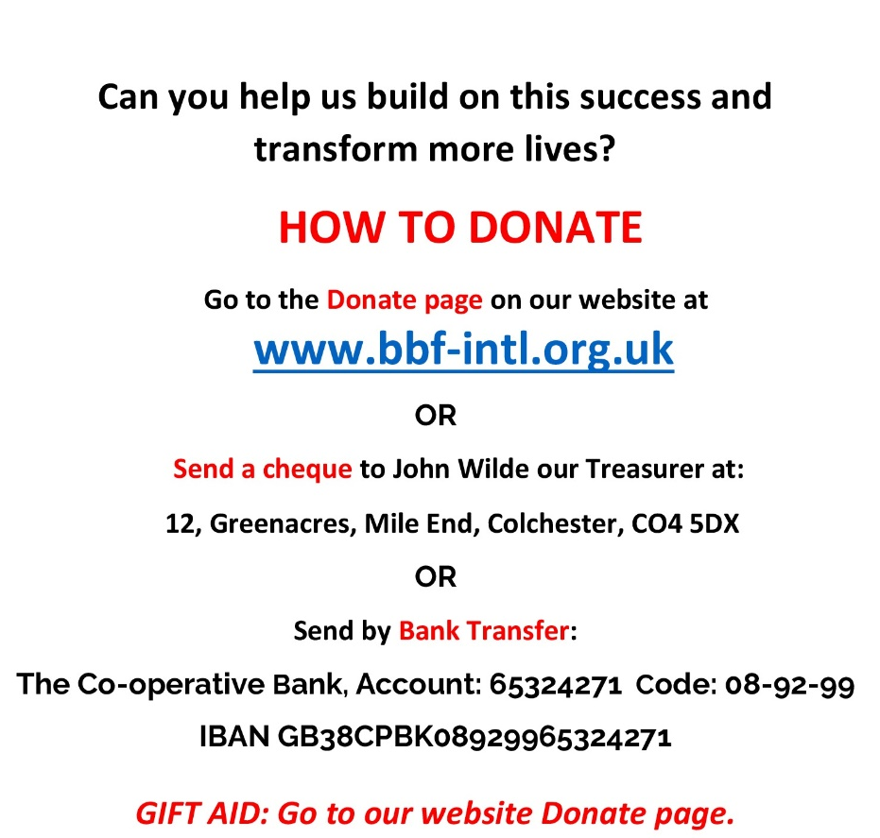
HOW TO DONATE:
Go to our website and click on the Donate link. www.bbf-int.org.uk



